
PATH 300
lecture #: | date: | professor:
21 | 27/03/2007 | Dr. Zorychta
22 | 29/03/2007 | Dr. Richardson
announcements:
- NTCs: The last day to pick up NTCs is April 11th. PULS does not have office hours after this date, so please be sure you have all your sets by then! Sets 12 and 13 will be available online through Athena: athena.susonline.net. Please email path300ntcs@gmail.com with any questions or comments.
- Course Evaluations: Online evaluations are available now through April 12th on Minerva. Everyone who completes evaluations is automatically entered to win an 80GB iPod!
set #11

Lecture 21 March 27, 2007

NEOPLASIA: PART IV Chapter 6

CARCINOGENESIS
- After discussing the many types of cancer, today we will be discussing what actually goes wrong in the cell for it to develop into this state.

History:
- In 1977, it was known that cancer was a fundamental abnormality in cell growth, but the understanding of control mechanisms for the cell was limited at the time.
- In 2007, the understanding about these mechanisms within the cell [i.e. those that control growth] and the mechanisms that control cell signaling has grown immensely, but we still have much to learn.
- The idea that environment could cause or contribute to cancer originated more than 200 years ago in 1775 when it was observed that boys working as chimney sweeps often had high rates of scrotal cancer.
  - It was assumed that something in the chimneys was the cause of this susceptibility.
  - The Danish Guild of Chimney Sweepers passed a law that these sweepers had to bathe once a day. Thankfully, this solved the problem and gave a start to the basic link between cause and effect.
    - However, at the time, they did not realize that the soot contained carcinogens nor did they know that the cells accumulated several mutations from this soot.
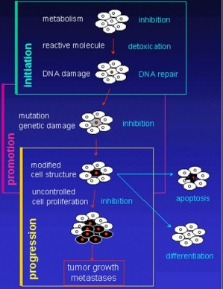
- Therefore, cancer is fundamentally an acquired disorder of DNA. We know a lot about DNA and about what controls gene transcription, which has allowed us to figure out a lot about what is going on in cancer today.

The Stages of Cellular Carcinogenesis:
- See the diagram to the right for a simplified overview of the stages of carcinogenesis and specific occurrences that occur in each stage.
- Carcinogenesis occurs in three stages:
  - Initiation: the initial events that take place in a cell that permit uncontrolled cell growth
  - Promotion: providing the environment in which the cancer cell can grow out of control
  - Progression: additional changes that take place to allow the cell to become more abnormal and develop properties that allow it to invade and metastasize

Genetics and Cancer:
- To classify the genes that contribute to cancer, there is the creation of two categories:
  - Oncogenes, which accelerate growth and division in cells to promote cancer.
  - Tumor suppressors, which inhibit cell proliferation thereby preventing cancer.

Oncogenes:
- There are essential and normal genes in cells responsible for regulating cell growth. These genes are referred to as proto-oncogenes.
- A mutation in one proto-oncogene can cause it to become hyper-active and stimulate abnormal cell growth. The mutated gene is considered an oncogene.
  - Mutations can occur through deletions, insertions, or translocation between chromosomes
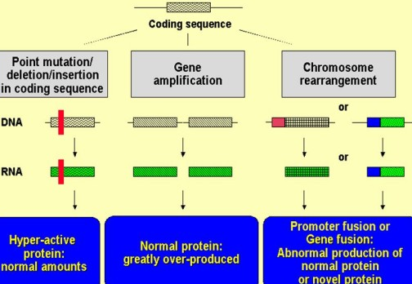
- Mechanisms of oncogene activation include:
  - Point mutation: the change of one amino acid to code for different protein that is hyper-effective
  - Gene amplification: the production of multiple copies of a given gene, causing an increase in overall protein production
  - Chromosome rearrangement: increased production of normal protein or rearrangement can encode for an abnormal protein, which causes an increase in cell proliferation
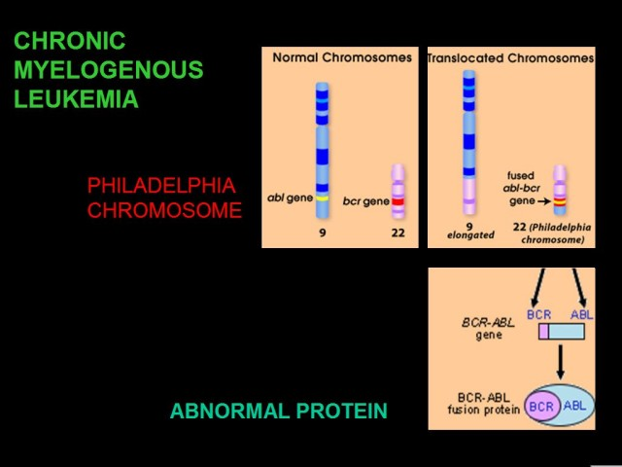
    - Translocation of the long arms of chromosomes 9 and 22 create a distinct chromosome 22, called the Philadelphia chromosome. It was first recognized as characteristic feature of chronic myelogenous leukemia. In time, it was realized that the fused gene [after translocation] codes for an abnormal protein, which causes cancer susceptibility. We will be discussing this further below.
    - Another outcome of translocation includes an increased transcription of a gene if promoter is relocated next to it.
      - e.g. c-myc oncogene, which involves translocation of chromosomes 8 and 14 and is involved in Burkitt’s lymphoma.

    - Chromosomal painting can now be used to detect translocations.

- How does one then move from mutation to increased cell proliferation?
  - If we look at the regulation of cell proliferation, there are six things that need to be analyzed:
    - Growth factors: cell growth is controlled by interaction and signals
    - Growth receptors: which interact with growth factors to activate cascades
    - Signal transduction pathways: activated by interaction of growth factors and their receptors
    - Transcription factors: activated by the signal cascade to signal proliferation
    - Apoptosis: to keep checks on cell proliferation by causing cell death
    - Cell cycle: is regulated to inhibit cell proliferation

- Oncogenes can:
  - Produce growth factors that are normally active and produce them in excess.
  - Make growth factor receptors that are hyperactive
  - Signal transduction factors at any step within the cell
  - Alter the activity of transcription factors
- All of these factors can cause an increased amount of or abnormality in any of the proteins at any stage, which can cause the problem

- Let us examine an example in breast cancer. Although we must remember that no two tumors are exactly alike, within any given patient there is a combination of these abnormalities.
  - Affected proteins in the cascade that are implicated in breast cancer are:
    - Growth factor oncogenes, which include bcl-1
    - Growth factor receptor oncogenes, which include c-erbB-2
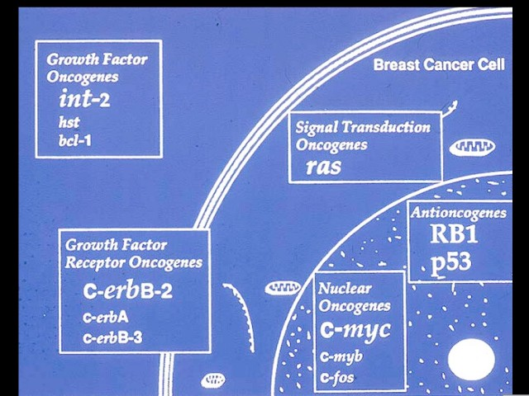
    - Signal transduction oncogenes, which includes ras
    - Nuclear oncogenes, which include c-myc
    - Anti-oncogenes [loss of function in tumor suppressors], which include RB1 and p53

- To convert proto-oncogene to oncogene: there only needs to be one change in a gene for it to be enough to code for the production of abnormal protein that will stimulate cell growth.
  - Let’s look at some examples:

Ras
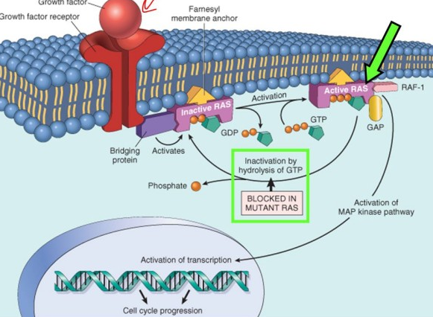
  - Ras mutations are very common in cancers and causes continuous signal transduction. The mechanism is as follows:
    - Stimulation of a receptor activates Ras, which is helped by phosphorylating GDP to GTP.
    - Activated Ras can activate the MAPKinase pathway, promoting transcription and allowing the cell cycle to continue.
    - Point mutations in Ras causes active Ras to not be able to hydrolyze GTP back into GDP and the protein stays turned on all the time, constantly stimulating the cell even when there is no growth factor present to bind to the receptor.
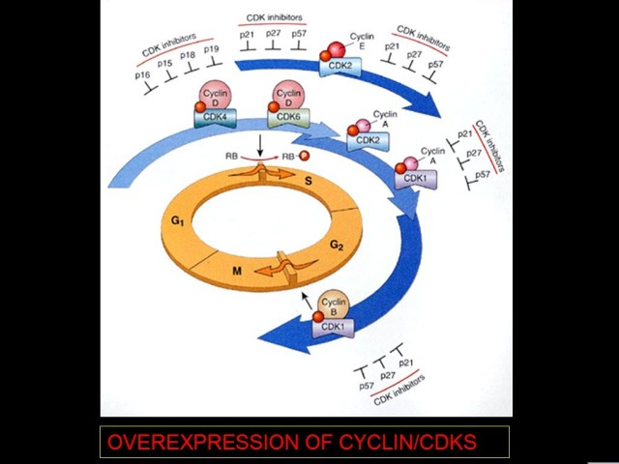
Cyclin/CDKs: ___________
- Cyclins and Cyclin-Dependent-Kinases [Cdks] are involved in regulation of the cell cycle.
- Passing from G₁ to S Phase and from G₂ to M Phase are major checkpoints in the cycle. Note that the checkpoints have extra proteins to control passage through these stages.
- As you can see in the diagram to the right. cyclins and Cdks stimulate the cell cycle, but there is also the presence of inhibitors of the Cdks.
- Therefore, controlling cell proliferation includes control of Cdks, cyclins and Cdk inhibitors.

Apoptosis:
- Blocking apoptosis causes cells to over-proliferate.
- An example of a protein that blocks apoptosis is Bcl-2, which blocks the mitochondrial role in apoptosis.
  - This protein is expressed in many cancers, which means that the tumor cell does not self-destruct when it should.
  - This can cause additional problems because many anti-cancer drugs work by promoting apoptosis in the cell. In these cases, Bcl-2 can prevent these drugs from functioning.

Back to Oncogenes and Cancer:
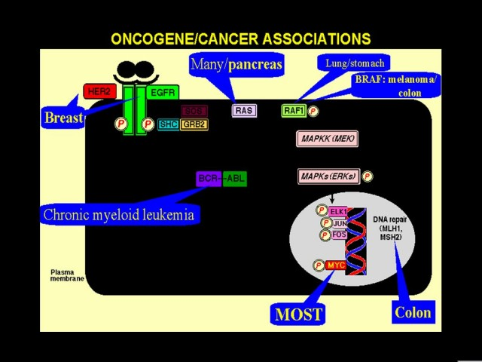
- Remember that every cancer is different, but all will express some oncogenes that stimulate excessive cell growth.
  - Examples include:
    - Breast cancer cells show increased expression of growth factor receptor [HER2 and EGFR]
    - Chronic myeloid leukemia shows fusion of BCR and ABL genes.
    - Colon cancer shows a defect in the DNA repair molecules MLH1 and MSH2.
    - Lung and stomach cancer show increases in RAF1
    - Pancreatic cancers show increases in Ras
    - And most cancers in general show increases in the transcription factor myc.

- Remember that we inherit genes from both our mothers and our fathers. Therefore, there will be two copies of all the alleles in your body. The deregulation of cell proliferation can occur even with the disruption of just one of these oncogene alleles.

Tumor Suppressor Genes:
- These genes normally produce proteins that dampen or inhibit cell proliferation through suppression of the cyclin-CDK stimulation or affecting checkpoints to stop the conversion of G₁ to S Phase.
- Recall that we have two alleles of each gene. However, in opposition to oncogenes, if you lose one tumor suppressor allele, the other one will still function to make the inhibitory proteins. You must lose both of your tumor suppressor alleles to deregulate cell proliferation.
  - This is called the two-hit hypothesis.
- Tumor suppressors can suppress the cell at any stage from surface signaling of cell to DNA transcription.
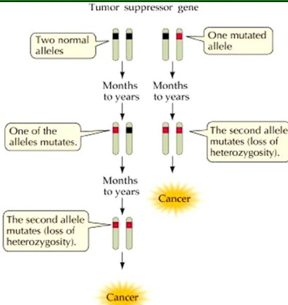
Retinoblastoma and Inheritance of Mutated Alleles:
- Consider the case if an individual is born with one mutated gene: this makes it easier to accumulate mutations to lose the remaining allele in the same cell compared to having to accumulate mutations that lead to a defect in both alleles in the same cell. Please refer to the diagram to the right. To discuss this, let’s consider retinoblastoma [RB].
- The normal chromosome 13 makes inhibitor protein. If you lose the RB locus on one allele, you can still make normal protein, but not if you lose the second RB. If this happens (rare) you have sporadic retinoblastoma.
- In addition, one can inherit a genetic defect [mutation] of one RB. Therefore, all the cells are born with one defective allele and it may just be a matter of time before you lose/mutate the second allele in one or more cells causing tumor formation in the eye of the affected child.
  - All it takes is one cell to have complete loss of both alleles to start tumor formation.
    - In the case of inherited RB, babies show advanced eye tumor formation by 18 months.
- If both normal alleles are present in most cells, there can still be one cell with a mutation. However the chance of a mutation occurring in the same cell on the opposing allele is very low, and there must be the loss of both alleles in the same cell for tumor formation to occur.
- The risk of developing RB is essentially gone when the individual reaches 7-8 years old because there is no more rapid cell growth in the region.
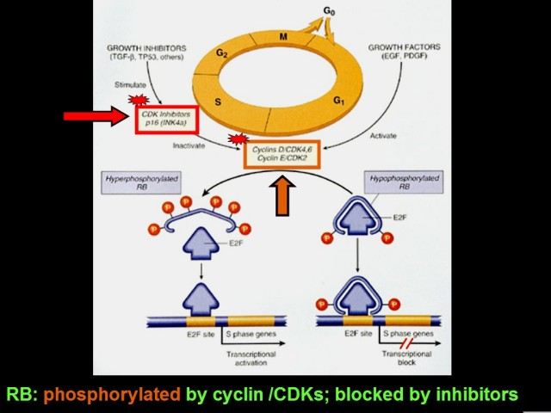
- The normal function of the retinoblastoma protein involves attachment to a transcription factor, which binds DNA to block transcription. This blockage of transcription involves regulating the cell cycle from G₁ to S Phase. When the cell is under normal control and should proliferate, the RB protein is hyperphosphorylated and detaches from transcription factor, no longer blocking transcription and the cell cycle can progress into S Phase. See diagram to the right.
  - To control the function of RB, it is phosphorylated by cyclin/CDKs. In addition, there are a series of growth inhibitors to block this phosphorylation.

An Example: APC Protein
- Tumor suppressor genes are located on various chromosomes.
  - e.g. Chromosome 5 has an APC involved in familial polyposis in intestine. We discussed this disease previously.
- The APC protein regulates beta-catenin, which normally activates a transcription factor promoting cell proliferation [as long as there is external stimulus and proper intracellular signaling]. See the diagram on the right for a graphic illustration of each of the discussed pathways.
- When a signaling pathway is not activated, beta-catenin is broken down in a destruction pathway that involves APC. The constant destruction of beta-catenin inhibits proliferation.
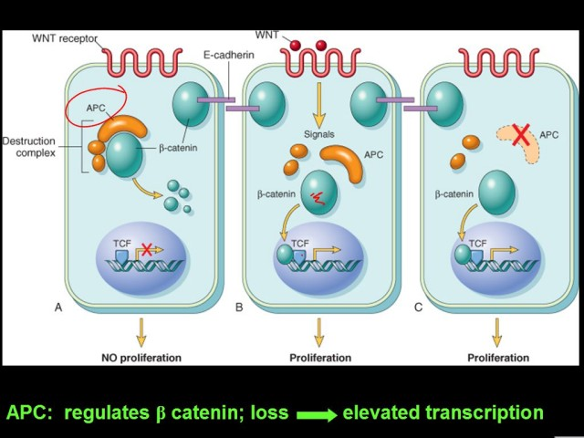
- If you lose the ability to make APC, your body is no longer breaking down the compound so it will accumulate to sufficient levels to stimulate cell proliferation even when it is inappropriate.
  - The link between the signaling and cell proliferation is lost.

P53: Gatekeeper of the Cell:
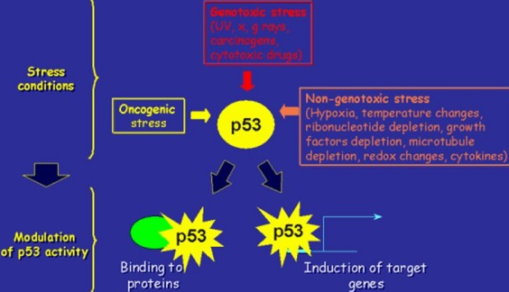
- Regulates both progression through the cell cycle and repair of the cell after damage.
- Located on chromosome 17.
- Responds to multiple forms of stress, including genotoxic stress [UV rays and carcinogens], non-genotoxic stress [hypoxia, temperature, etc], and oncogenic stress. See the diagram to the right for further details.
  - These stresses cause the production of p53 protein, which stimulates transcription of a series of target genes, so the cell responds to damaging agent.
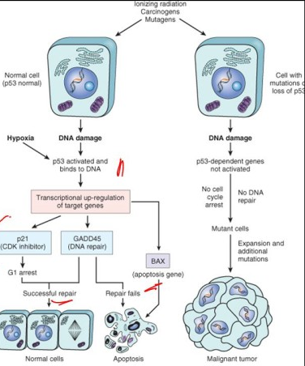
- Mechanism of Action:
  - DNA damage in the cell.
  - The cell senses this and increases production of p53.
  - The increase in p53 causes the cell cycle to halt and turns on genes involved in DNA repair by forming a tetramer [e.g. p21, which is a Cdk inhibitor; GADD45, which causes DNA repair; Bax, which causes apoptosis if the cell is damaged too much]
  - The cell is paused long enough to repair itself and then it re-enters the cell cycle.
  - If DNA repair does not occur, p53 signals apoptosis and the cell self-destructs.
- This is an important quality control mechanism because DNA mutations are not that unusual.
  - Mutagenic sources include sunlight, food chemicals, free radical formation as a by-product of metabolism, etc. These mutations are detected and corrected by the cell and p53 is an integral part of this process.
- If there is a mutation in p53, the cell will not stop replication correctly, its DNA repair mechanisms will not be brought in properly, and there will be no apoptosis.
  - This causes risk for a malignant tumor.

- p53 is an extremely important protein in cancer. Mutations causing cancer are often point mutations in the DNA binding domains of p53. Mutations can also occur in the tetramerization domain, but are less likely.
  - Examining benzo[a]pyrene, a classical carcinogen of lung cancer, we can determine:
    - That codon 175 and 273 are common sites for alterations in p53.
    - Comparing the frequency of specific point mutations in lung cancer and in other cancers; GC-AT is common in all cancers and GC-CG particularly common in lung cancer.

- Those born with one defective p53 locus are at higher risk of developing p53 related tumor. Although this is rare, it is the basis of the Li-Fraumeni syndrome.
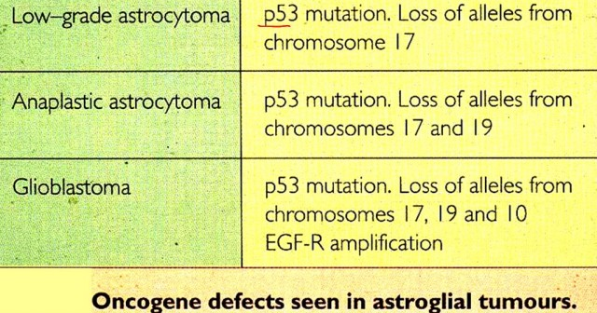
  - This is associated with breast cancer, brain cancer, soft tissue sarcoma, leukemia, osteosarcoma, and adrenal carcinoma.

- In addition, once p53 is lost, the chance of accumulating other mutations in other genes is greater because the cell has lost an important quality control mechanism regulating growth.
  - See the chart to the right, which shows the problems that can occur with loss.

DNA REPAIR
- If DNA repair is not occurring normally, it may lead to tumor formation.
  - e.g. rare familial breast cancer has defects in the DNA repair gene BRCA.
- Additional mutations to the DNA normally occur once you have the tumor.
  - This allows the development of sub-clones that allow metastasis, release of angiogenic factors, release of lytic enzymes to break down extra-cellular matrix, recruitment of other cells, etc.

Motility:
- Normally, an adhesion plaque holds the cell down, connecting to actin, which is bound to series of proteins like vinculin. In tumor cells, there are proteins with tyrosine kinase activity that can be produced that disrupt adhesion plaques through phosphorylation of the glycoproteins. This causes cell detachment, which means the tumor cell is loose and can travel elsewhere to spread.
- In addition, tumor cells are able to secrete proteases and block anti-proteases, which enable the tumor cells to break through the basement membrane and extracellular matrix.
- Tumor cells also make cell adhesion molecules that bind integrins and fibronectin.
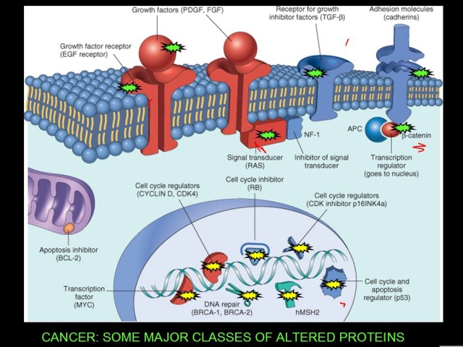
- They can secrete motility factors that feedback on its own activity, which allow it to invade and progress to surrounding tissue.

Cancer: some major classes of altered proteins
- Let’s take a look at the big picture again.
- A combination of mutations in any of: growth factor, its receptor, the signal transducer [Ras] or growth factor inhibitors, transcription regulators, DNA repair, apoptosis, cyclins, and CDKs will lead to formation of tumor cell, which will accumulate other mutations. The extra mutations occur because these cells are genetically unstable and cannot fix themselves.

- Through microarray analysis we can characterize genetic mutations and changes taking place in tumor cells.
  - The test involves taking normal and tumor tissue from same patient [each labeled with a different color in their DNA], hybridizing the cDNAs to one microchip and comparing the two to determine which genes are over and under expressed in tumor cells.

CARCINOGENESIS: FROM MOLECULAR MECHANISM TO CHEMOPREVENTION
- What happens to allow cell growth to go out of control?
  - Chemicals
  - Viruses and bacteria
  - Radiation
  - Heredity [smallest contribution]

Chemical Carcinogens:
- Bind to DNA to alter it. The end result is DNA damage, leading to cancer.
- Often chemical carcinogens need to be converted from precursor to reactive form via intrinsic cytochrome p450 enzymes.
- An example is radiation, which produces free radicals.

Viruses:
- An example is the Human Papilloma Virus [HPV], which is the culprit behind cervical cancer
  - Here, the virus makes proteins that inactivate the RB protein, which controls the cell cycle and the p53 protein, which is another tumor suppressor. Therefore, there is a double hit with this virus because the virus eliminates two of the major protective measures.
  - Cervical cancer is major problem accounting for a large number of cancer deaths globally.
- Other examples include:
  - Hepatitis B: causes hepatocellular carcinoma [liver cancer]
  - Epstein-Barr virus [EBV] causes non-Hodgkin’s lymphoma, nasopharyngeal carcinoma and Burkitt’s lymphoma
  - Cytomegalovirus [CMV] causes Kaposi’s sarcoma
  - Human T-Cell lymphotropic virus causes T-Cell leukemia
  - Epstein Barr virus causes Burkitt’s lymphoma
    - Many of us have been exposed to this.
    - By itself is not capable of causing cancer, but requires co-factor to initiate the changes.
      - Often, malaria is common co-factor.
- Mechanism of Action for Viruses to Cause Cancer:
  - Blocking inhibitory proteins [tumor suppressors]
  - Insertion into DNA and act as a promoter to increase expression of an oncogene
  - Blocking apoptosis forever.
    - e.g. Epstein Barr Virus
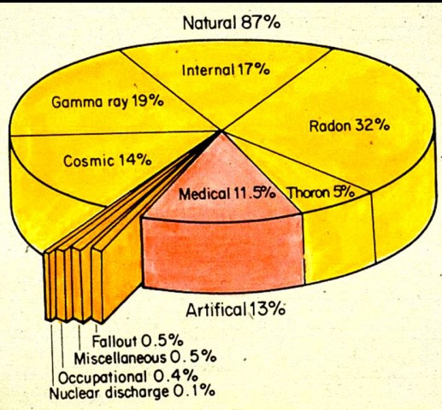
    - This mutation is commonly found in B-Cells. T-Cells work to keep these immortalized B-Cells controlled, but this check is disrupted when the individual has malaria.

Radiation:
- Produces free radicals that then damage DNA [via strand breaks, deletions, translocations, base pair alterations, cross-linkages].
- Example: Radium poisoning was not initially recognized, but in the early 1900’s, glowing dials on watches were painted with radium and the painters would put their brush in their mouth, unaware of the toxicity – many later developed cancer.
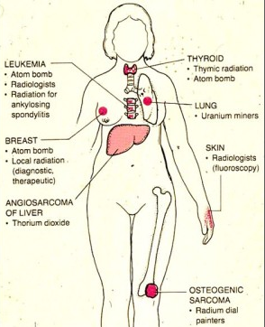
- Most of our exposure to radiation is natural and a small amount is from medical testing. However, there are other causes: see the diagram to the right.
- Some radiation-induced tumors can occur from accidents and WWII atomic bomb. To see possible locations of tumors, refer to the picture at right.
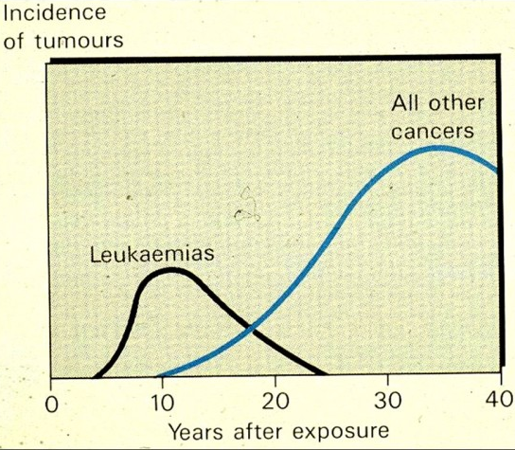
- Incidence of Tumors due to Radiation: Leukemia appears earlier then other cancers, which appear after a period of ~ten years after the point of mutation
  - This is seen in Chernobyl, when thyroid cancer in Ukrainian Children appear with a sufficiently long with lag time [~8 years]

- Summary:
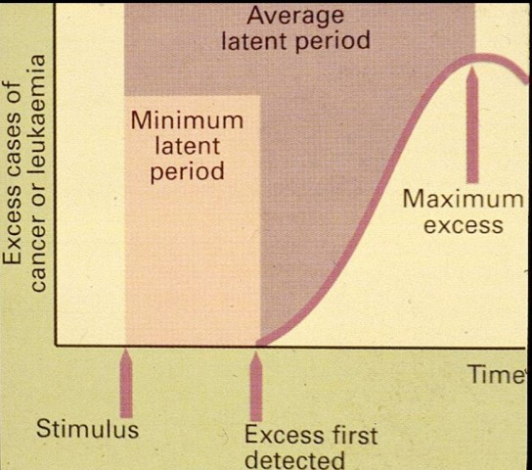
  - After DNA damage from initial radiation, cells become genetically unstable and it is only matter of time before they can accumulate enough mutations to start a tumor.
  - The tumor must double in size a number of times before it is big enough to be detected and the individual experiences clinical symptoms.

  - And although your immune system is great in a test tube, it doesn’t protect you much in this case.

Other Factors:
- It is crucial to remember that it takes more than one genetic change before you end up with tumor.
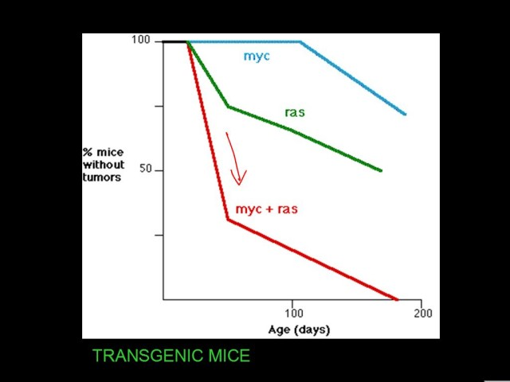
  - For example, the rate of tumor development in mice with both Ras and myc mutations is increasingly higher than compared to single mutations of each.

- Studies of genetic changes in colon polyps [precursor of colon cancer] allowed us to work out a sequence events of cumulative mutations leading to invasive cancer.

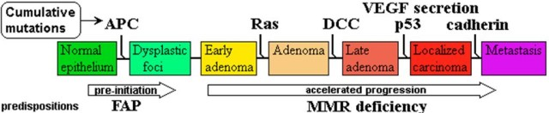

- Finally, chronic inflammation has been linked to cancer due to free radicals and damage to DNA.

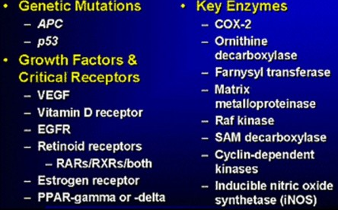
MOLECULAR TARGETS FOR COLORECTAL CANCER CHEMOPREVENTION:
- The slide to the right is a list of possibilities in which the target therapies may work.
- Currently, work is being done not only to understand what is wrong in the tumor cell and to make drugs for treatment, but also to prevent it in the first place.

THERAPY
- The biggest success today is in curing childhood cancers, mainly through chemotherapy.
  - Chemo has been beneficial for adult tumors as well as pediatric tumors
  - e.g. leukemia, CNS tumors, Wilms’

- Therapy is based on four major strategies:
  - Surgery: colon, breast, ovary, lung, thyroid, skin
  - Chemotherapy: lymphoma, leukemia, choriocarcinoma, ovary, can be used combined with surgery
  - Radiation: seminoma, breast, uterus, cervix, lymphoma, lung, combined with surgery
  - Hormones: breast, prostate, endometrium

Surgery:
- Does not have to be necessarily major. There are less invasive procedures.
  - e.g. freezing a tumor in liver
- When doing surgery, the most best way to monitor if it was effective is using a tumor marker, which is monitored via the blood level
  - If large sized tumor is removed, the level in blood should drop dramatically. However, if the blood level of tumor marker remains unchanged, the tumor is still present, and if the blood level rises, then tumor is recurring.

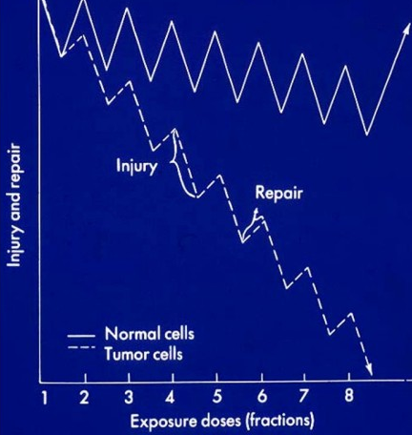
Radiation:
- Classically used.
- Brachytherapy is used for more localized radiation.
- External beam radiation, as with all forms of radiation, it is important to get exact dose to ensure the technique to affect the tumor, but not cause extensive damage to normal body.
- Repeated radiation therapy is necessary because there is inevitable damage to some normal cells while damaging tumor cells, but tumor cells are less able to repair themselves. But the normal cells can recover. Therefore, you must wait for this to occur.
  - Since tumor cells repair less, they eventually accumulate excessive injury and die.
  - The goal is for normal cells to be fully recovered and tumor cells to perish.
- Sometimes there will be a period of complete remission, where number of tumor cells will drop below level that will cause person symptoms, but the levels may rise again.

Chemotherapy:
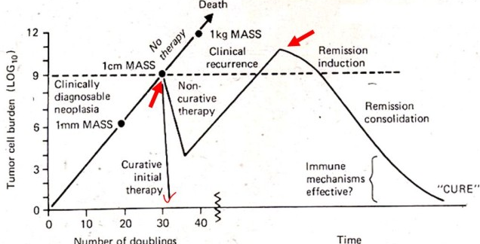
- Occurs through intermittent doses of drug [for same reason as with radiation].
- After treatment, if you are lucky you can cure the tumor right away. If you are unable to cure it, but tumor responds, you can go into remission where you have no symptoms for a period of time. Eventually though, the tumor may re-grow and you will begin to get symptoms again. Death occurs when tumor grows to beyond 1kg.
  - It is also possible to go into multiple remission states, especially if a different drug therapy is used.
- Chemotherapeutic drugs are most effective on rapidly dividing cells.
  - Many exist and act at different stages of cell cycle, while others act by triggering apoptosis.
  - Patients are often given a combination of many drugs to avoid drug resistance and decrease toxicity.
  - Burkitt’s Lymphoma is one of most responsive tumors to chemotherapy because the cells grow so fast and child can be cured, if treated.

SIDE EFFECTS:
Of Chemotherapy:
  - In addition to apoptosis of cancerous cells, there is also apoptosis of regular tissue cells.
  - The cells in the crypts of your intestine are good targets for chemo, due to their high growth rate [we shed over 1000 cells/day from each villus]. This can lead to unpleasant GIT side effects.
  - Hair loss and skin problems also common.
  - Chemo can save your life or induce long periods of remission

Immunotherapy:
- Attempts to develop a more selective approach to knock out a tumor causing fewer side effects.
- To do this, you need to manufacture an antibody against specific antigen on tumor.
  - Ideally, you can target more than one antigen because tumor cells are heterogeneous, so you are able to use combinations of antibodies directed against multiple antigens.
    - We presently have monoclonal antibodies that can be used as well as experimental cytokines.

Pain:
- While anti-cancer medications are being administered, it is important to provide pain medications because until the treatment is able to the shrink tumor, patient will experience pain, especially from bone metastasis.
  - Strategies exist to increase analgesics and create combinations of analgesics to carry on with lives, especially in terminal cancer patients.
- This is done with pumps or repeated administration at frequent intervals to keep high dose of analgesic to avoid suffering.

NEWER DRUGS
- Discoveries leading to FDA approval of STI571/Gleevec for treatment of chronic myelogenous leukemia.
  - The Philadelphia chromosome was recognized in 1960 and many studies were done until the 1980’s when it was understood that the oncogenic protein formed from translocation.
    - Studies and testing followed to find drug that blocked the abnormal protein.
    - Drug is now on the market as treatment.

- There are many strategies with monoclonal antibodies:
  - By recognizing an antigen on a tumor cell.
  - By recognizing a tumor antigen and destroys cell, due to toxic attachment to the antibody
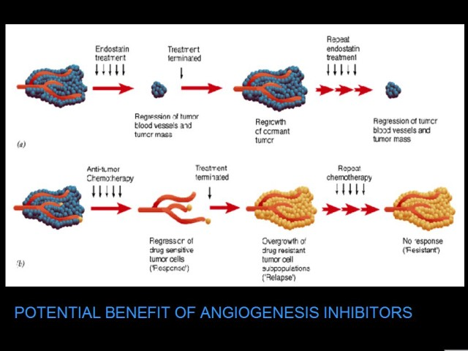
    - e.g. a radioactive component called radioimmunoconjugate, or immunocytokine, or immunotoxin
  - Slowly this is becoming more feasible.

Angiogenesis:
- Feature needed for tumor growth and therefore can be targeted for therapy.
- Angiogenesis inhibitor drugs exist.
- Compare tumor treated with angiogenesis inhibitor vs. chemotherapy in the diagram on the right.
  - In both cases there are a reduced number of cells that could survive and the patient is symptom-free.
  - Both show tumor re-growth after drug is stopped. The difference is that you can repeat treatment of anti-angiogenesis drug and get relief of symptoms and not have bad side effects, still without curing. For chemotherapy , you must change to different drug because the tumor cells are now resistant to the drug (the tumor is now derived from the few cells that were able to survive the drug).
- These drugs may not cure the cancer but do have useful properties

Inflammation:
- Plays a role in development of many tumors.
- Tumors trigger inflammation and macrophages and T-Cells are recruited to tumor sites to release chemokines, vascular growth factors [VEGFs], cox-2, etc.
  - This understanding led to the development of drugs targeting proteins involved in inflammation.
    - e.g. cox-2 inhibitors are of major benefit when combined with other anti-cancer drugs.

The Primary Tumor:
- There have been many therapies focused on the primary development.
- Now, we are taking a better look at the steps in metastasis and the signaling between the secondary tumor site and the cancer cells that move around the blood shed by the primary tumor.
  - There is questioning into whether you can block metastasis via these methods.
    - Models have developed metastasis in vitro: gather cells and place on matrix to see if they are able to dissolve through matrix and metastasize. This can then be used to test drugs to see whether they prevent this.

Others:
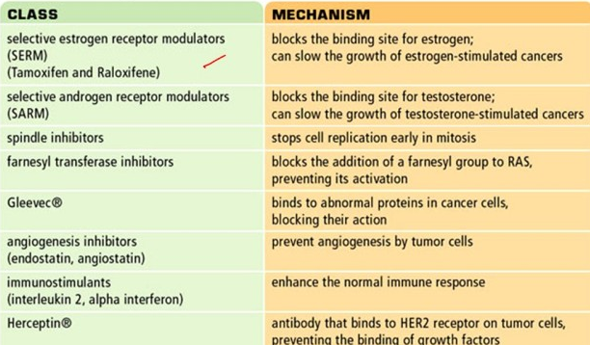
- Some selective drugs available:
  - Hormone modulators
  - Protein blocker
  - Angiogenesis inhibitors
  - Monoclonal antibodies
  - See the chart to the right.

- Chemoembolization:
  - Can inject an anti-cancer drug into the tumor of liver cancer, which is universally fatal.
  - There is a separate component that will block the drug from moving to other areas in the body

RISK FACTORS
- Cancers are more prevalent in certain parts of world because of environmental influences.
  - Canada ~ leukemia
  - U.S. ~ colon cancer
  - Brazil ~ cervical cancer
  - U.K. ~ lung cancer
  - China ~ liver cancer
  - Japan ~ stomach
  - Australia ~ skin cancer
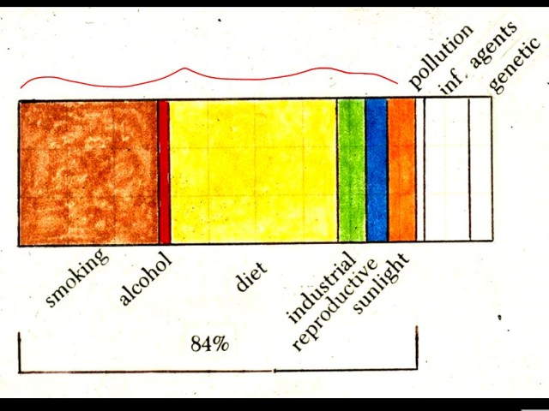
- When people move to new place, they take on new environmental risk factors. Environmental risk is biggest component for most cancers.
  - However, certain diseases, such as familial retinoblastoma, have a big genetic component.

- Infections, such as HPV and bacterial infections
  - ~ 1.5 million cases – mostly stomach and cervix
- Diet
  - ~ 3 million cases
- Smoking Carcinogens
  - ~ 3 million

- Must remember to look at all experiments and components critically.
- We have different ways of testing for carcinogens, e.g. using and AMES test
  - Here, we can say that a toxin present in contaminated food in some countries [aflatoxin B₁], a potent mutagen and cause of liver cancer is a carcinogen even at low doses
  - However, saccharin is needed in extremely high concentrations to have carcinogenic effect.
- In the big picture, smoking, alcohol, diet, and sunlight are the cause of the vast majority of cancers. These are completely preventable environmental factors.
  - Living next to electric lines has not been proven to be much of a risk of cancer.

PREVENTION
- We need to protect ourselves against chemical carcinogens, radiation and viruses.
- In addition, you need to examine each stage in the development of a cancer and target each individually for prevention.
- Possibilities include: do not smoke, wear sunscreen, eat healthy diet
- Other things are controversial: green tea, some drugs like NSAIDs may be beneficial
  - The studies are ongoing:
    - In 2005, the Mayo clinic began coordinating clinical trials on chemoprevention of seven types of cancer
      - Ideally, we should be able to prevent most of them.
- In terms of diet, fruits and vegetables are important and some important compounds in cabbage family.
- No great evidence that vitamins are protective against cancer, but they are needed for other reasons.
- Vaccination against HPV is a new preventative measure against cancer and is available all over North America.
  - The incidence and mortality of cervical cancer is high in Central and South America, South Africa.
    - 900 000 women per year have cervical cancer worldwide.
    - More than 80% are in stages 3 and 4 with a 20% 5-year survival rate
    - All they need is immunization against HPV to prevent this cancer.
    - HPV can cause cancer in men, but it mainly afflicts women.

Lecture 22 March 29, 2007

GASTROINTESTINAL PATHOLOGY 1/3 - Chapter 15

- Gastrointestinal (GI) symptoms are common and usually intermittent
  - They can be caused by a virus or temporary illness.Their persistence could be a sign of something more serious. They include…
    - Nausea, vomiting, heartburn, gastritis, anorexia, gas pains, diarrhea, constipation
  - GI illnesses include achalasia, ulcers, cirrhosis, hepatitis, tumors, colitis.

- Endoscopy
  - Important instrumentation in examination, diagnosis, treating and curing problems in GI tract.
  - Essentially, a tube with fibre optics is inserted in the oesophagus.
    - Visual projection onto a computer screen
      - Can see oesophagus, stomach, first part of small intestine
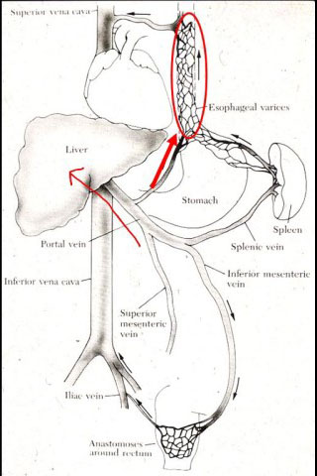
    - Microsurgical instruments included
  - Endoscopy avoids surgery. Mild sedation needed.

ESOPHAGUS
Squamous epithelial lining (vs columnar cells lining stomach)

- Esophageal Varices
  - I.e Varicose veins in esophagus.
  - Caused by liver problems
    - If blood flow to the liver is impaired (e.g cirrhosis), the blood is shunted through veins branching off the portal veins and going to the esophagus.
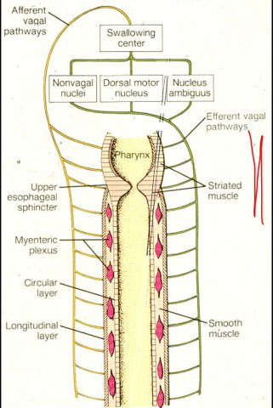
    - The high pressure in these fragile vein cause varices that wu\ill bulge out into lumen. They are therefore vulnerable to rupture and consequent hemorrhage.
  - Treatment; Seal off ruptured vessels.

- Swallowing
  - Esophagus functions in transporting bolus from mouth to stomach through swallowing.
    - Swallowing also has lubricant function. Also helps in clearing the airways, as macrophages from the airways have deposited bacteria on mucociliary blanket

  - Enteric Nervous System
    - in wall of esophagus and throughout GI system.
    - “Miniature Brain”
      - Extensive neuronal network; excitatory, inhibitory, interneurons, transmitters
      - Relay/Responds to autonomic or sensory input
      - Intercommunication between plexus
        - Myenteric
        - Submucosal
    - Controls Peristalsis, Sphincters, Vomiting, Release of enzymes
    - The ENS innervation allows to swallow even if hung upside down.
  - Frequency;
    - We swallow 1/min or 1000/day
    - 0.5mL of saliva every time.
    - No swallowing during sleep.
  - Swallowing is a complicated and highly co-ordinated mechanism
    - Voluntary control of initation of swallowing by by striated skeletal muscle in upper 1/3 of esophagus
    - Involuntary control along the lower 2/3 of esophagus and rest of GI tract through smooth muscles.
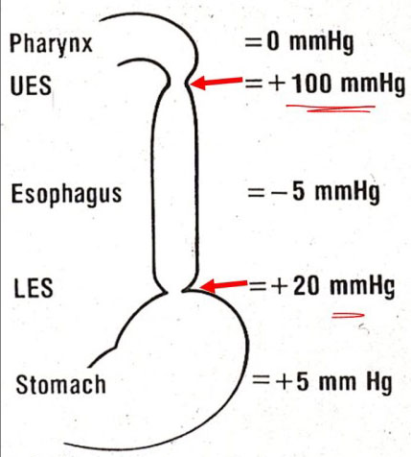
    - Activity coordinated in swallowing centre in medulla
      - 25 muscles, 5 cranial nerves

- Sphincters
  - There are two.
    - Upper Esophageal Sphincter(UES);
    - Lower Esophageal Sphincter(LES; at level of diaphragm, most problems occur here
    - Both are high pressure points. This keeps the food in place.

  - Achalasia = “failure to relax”
    - Incomplete relaxation of LES following swallowing. As a result, the food doesn’t pass or passes very slowly.
    - Symptom; Dysphagia (i.e. difficulty swallowing)
    - Achalasia is due to selective loss of inhibitory neurons in LES. Excitatory neurons are still working.
    - It is treated with drugs, in mild cases. Ballon dilatation can also be performed.

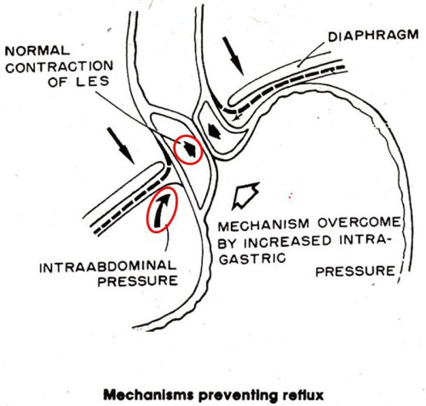
- Heartburn = acid reflux
  - Burning sensation in the left side or along the midline of chest.
  - HCl inside stomach refluxes above the LES into the oesophagus. The result is a burning sensation because the esophageal epithelial lining does not have protective mechanisms against acid.
    - Causes injury and inflammation. Can lead to difficulties if chronic.
  - Acid reflux is caused by…
    - Increased intra-abdominal pressure
    - Increased intragastric pressure
    - Sphincter contraction problems
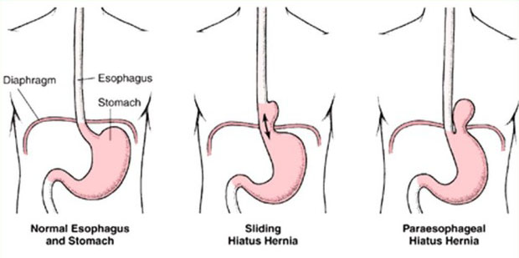
  - Hiatus Hernia could be a cause of acid reflux
    - Hiatus = opening in diaphragm that lets esophagus go through
    - Etiology; a dilation of the hiatus will make the LES incompetent. The consequent hernia follows two anatomical patterns
      - sliding hiatus hernia; most common - stomach protrude above diaphragm, into thoracic cavity
      - para-esophageal hiatus hernia; portion of the stomach along greater curvature enters the thorax
    - Symptoms
      - chest pain → pressure and inflammation due to acid reflux
      - fibrosis → scar tissue, due to healing
      - hyperplasia → squamous cells proliferate to protect wall against acid.
      - ulceration → formed when acid attacks wall of esophagus.
      - stricture → decrease in opening of esophagus
      - dysphagia → as a result
      - spasm → contraction of smooth muscle caused by irritation
      - Metaplasia → if injury persists.
    - Treatment
      - Avoid positions that allow for acid reflux
        - Stay upright to keep content in stomach, sleep with pillows
      - Weight loss, quit smoking (known to aggravate symptoms)
      - Antacids
        - Effective in neutralizing the acid. The food we now ingest is not filled with micro-organisms. Using an antacid that will neutralize the protective acid will therefore not be counter-productive.
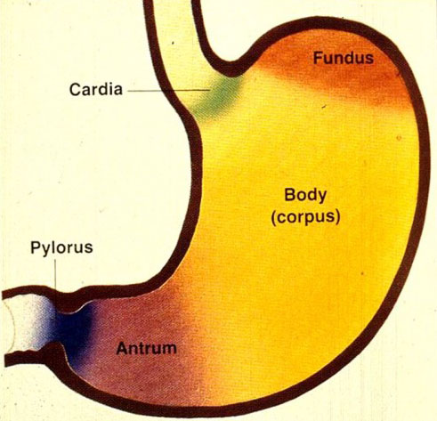
CANCER
Esophagus: Risk of squamous cell carcinoma increases with smoking and excessive alchohol consumption
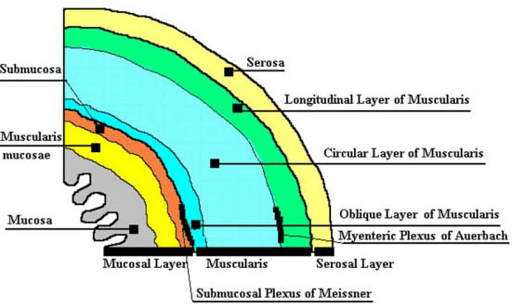
.

STOMACH

- Histology of stomach
  - Layers – uniform structurein all areas of stomach. See figure.
    - There is variety within the different regions as to the type and function of secretory cells.
  - Secretory cells
    - Mucous cells
      - Mucous covers wall of stomach so acid doesn’t come in contact with surface epithelium.
      - Mostly in fundus, but found throughout the stomach
    - Parietal Cells**
      - Mostly in the Body and Antrum of stomach
      - HCl produced by acid pump in parietal cells
        - Mechanisms controlling pump – 3 receptors. These are therefore targets for modulating acid output.
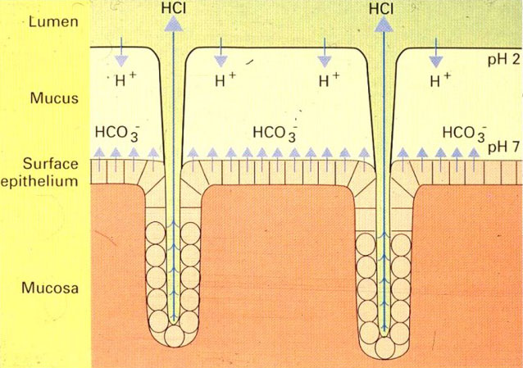
          - Gastrin
          - Histamine
          - Acetylcholine (by ANS)
    - Both mucous and parietal cells work together to avoid damaging the epithelial lining of the stomach (i.e mucous cells protect against damaging (HCL)
    - Ulcers are the result of an imbalance between acid output and mucosal defense.
      - i.e too much acid production or not enough defense.
- Treatment of ulcers
  - Incorrect hypotheses as to the etiology of ulcers lead to ineffective treatments and unpleasant lifestyle changes.
    - Historically, hot peppers, coffee, stress were named culprits. Treatment by restrictive diets, surgery to remove parts of stomach or cut vagus nerve
  - Target acid production
    - Antacids found to be effective, but need to use frequently
    - By impairing normal function of acid pump, the acid production is decreased thereby allowing the ulcer to heal.
      - Block H2 receptors of parietal cells to slow down the acid pump
      - Block the acid productioin completely with proton pump inhibitors
      - Allows scar tissue to form and mucous layer to be re-established.
  - Sequels and complications of peptic ulcer diseases
    - Spasm
    - Scar tissue-can cause stenosis and slow gastric emptying.
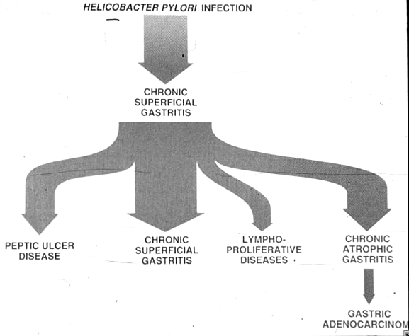
    - Recurrance of the ulcer – relief only temporary
  - Now use antibiotics against helicobacter pylori combined with acid reduction techniques
  - It took a long time before an effective treatment was found because of 1) false assumptions about the cause 2) the intermittent nature of the symptoms. It was hard to determine if the asbsence of symptoms was actually due to the treatment’s efficacy.
- Helicobacter pylori
  - Ingested – contaminated food.
    - Microorganism that can survive concentrated HCL. Its flagella allows it to burrow into mucous layers. It remains there, protected from the acid
  - Seretes proteins that trigger the release of cytokines, thereby causing a severe inflammatory reaction.
  - It is responsible for …
    - Chronic Superficial gastritis
    - A good fraction of stomach cancers (gastric adenocarinoma)
    - Peptic ulcer diseases

- Peptic ulceration
  - Affect mucosa of the GI tract, extending to the submucosa or deeper
    - Can occur anywhere between lower part of esophagus to upper part of duodenum
    - More prevalent in stomach (pyloric region) or duodenum
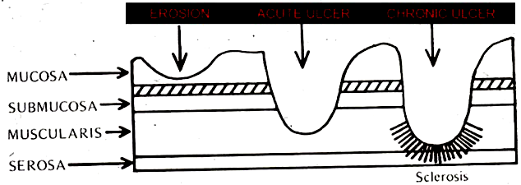
      - The age of onset for duodenal ulcers is slightly lower
  - Different levels
    - Erosion;
    - Chronic ulcer
      - Location; most common in antrum
      - Result in
        - Scar tissue
        - Necrosis
        - Can reach down to artery and cause bleeding.
        - Perforation to pancreas.
      - Risks of
        - Hemorrhage
        - Perforation
        - Stricture and obstruction.

- Acute ulcer = stress ulcers
      - Severe physiological stress with rapid onset.
      - Cause
        - Serious brain injury
        - Severe burns
        - Major surgery
        - Cardiovascular shock
      - Result:
        - Multiple erosions(ulcers)
        - Disruption of stomach and sometimes duodenal mucosal barrier.
        - Temporary ischemia.
        - Very deep (through submucosa).
      - Risk: Hemmorhage and perforation. Important to monitor patients at risk closely.

- Gastritis
  - Stomach inflammation
  - Causes:
    - Alcohol
    - Non-steroidal anti-inflammatory drugs (NSAIDS) and other drugs
    - Food poisoning
  - Result; Acute erosion of mucosa. Observed as red streaks on epithelium
  - Note that smoking significantly impairs healing

- Stomach cancer
  - Cure rate very low.
  - Causes:
    - Helicobacter pylori is major cause.
    - Smoking causes 20% of stomach cancers.
  - Enhanced food preservation with refrigeration and the use of antibiotics (for other causes, but it has an effect on H.Pylori) contributed to the decrease in mortality rates for stomach cancers

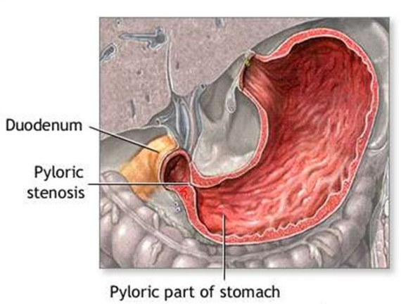
- Pyloric stenosis
  - This is a condition most commonly seen in infants - leads to projectile vomiting
    - Due to excess of muscle in wall
    - Vomiting shortly after ingestion
    - Incision is made to allow muscle to relax
  - Fatal in past but now treatable
  - Could also result from scarring from an ulcer

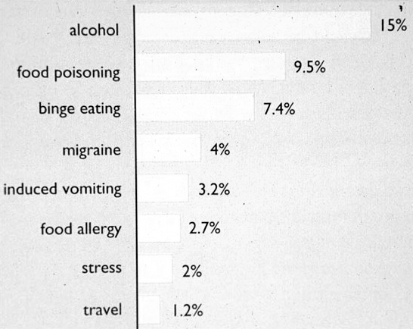
- Vomiting
  - Life-saving mechanism. Allows expulsion of toxic chemical ingested before a lethal dose is absorbed.
  - How is it induced?
    - Control mechanism; Vomiting Centre in Medulla
    - Usually caused by alcohol, food poisoning, bulimia
    - Nausea and vomiting most common in young adults (often due to excessive alcohol consumption)
  - Various input
    - Chemical
      - CTZ (chemoreceptor trigger zone): chemically analyzing blood, will react to foreign chemicals
    - Sensory
      - In the periphery, in GI tract. Abnormal chemical constitution or distention sends impulse.
    - Cortical; sends impulse in stressful situations.
  - Output
    - Afferent impulse sent down spinal cord to
      - Intestinal plexuses
      - Abdominal skeletal muscles
      - Diaphragm .
    - Pre-vomiting phase
      - Stomach relaxes
      - Reverse peristalsis (Antiperistalsis): Upper intestinal contents pulsated into stomach in some situations (ie. intestinal obstruction)
    - Vomiting
      - Sphincters open (relaxes)
      - Diaphragm contracts (comes down).
      - Abdominal muscles contract.
      - Stomach contents squeezed back up esophagus by external pressure.

  - Chemotherapy can cause vomiting
    - Trigger CTZ.
    - Chemotherapy affects cells with rapid turnover. The intestine is a region with high proliferation. There is consequent irritation which triggers peripheral vomiting sensors.
    - Anticipation causes chemo patients to vomit or feel nauseous before even receiving treatment.
  - Anti-Emetics
    - Much research on anti-nausea drugs.
    - Looking at vomiting pathways in the brain has been effective in discovering new drugs.
    - Now have drugs that can block vomiting centre.
    - Important drug involves 5HT3 receptor blocking.
    - Drugs given prophylactically to prevent nausea ie. prior to chemo treatment.

